**Issue#1**

|  |  |  |
| --- | --- | --- |
| DrugList | Choosing customer set name on main drug list search screen | .596 (1.4 with SW) |
| Pricing | Choosing master customer set name on main pricing search screen | 0.964 (1.0 with SW) |

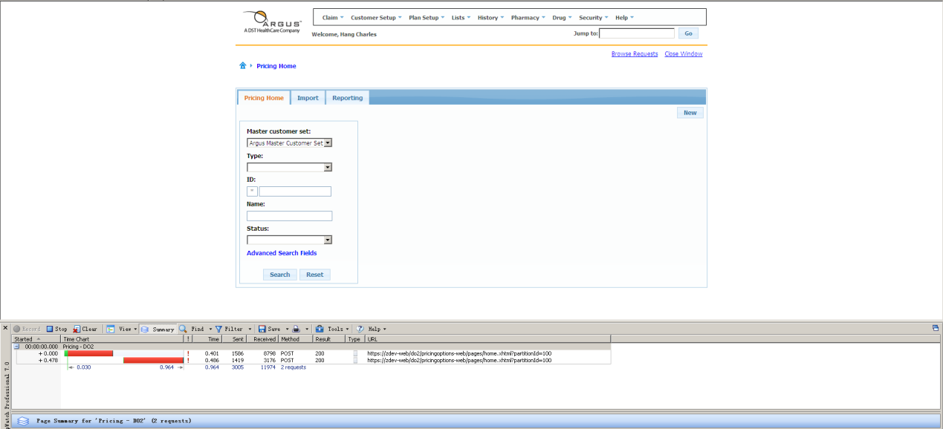

**Issue#2**

|  |  |  |
| --- | --- | --- |
| DrugList | Search to find a list to getting results | 1.098 (2.4 with SW) |
| Pricing | Pricing: Search to find a list to getting results page. | 1.919 (2.3 with SW) |

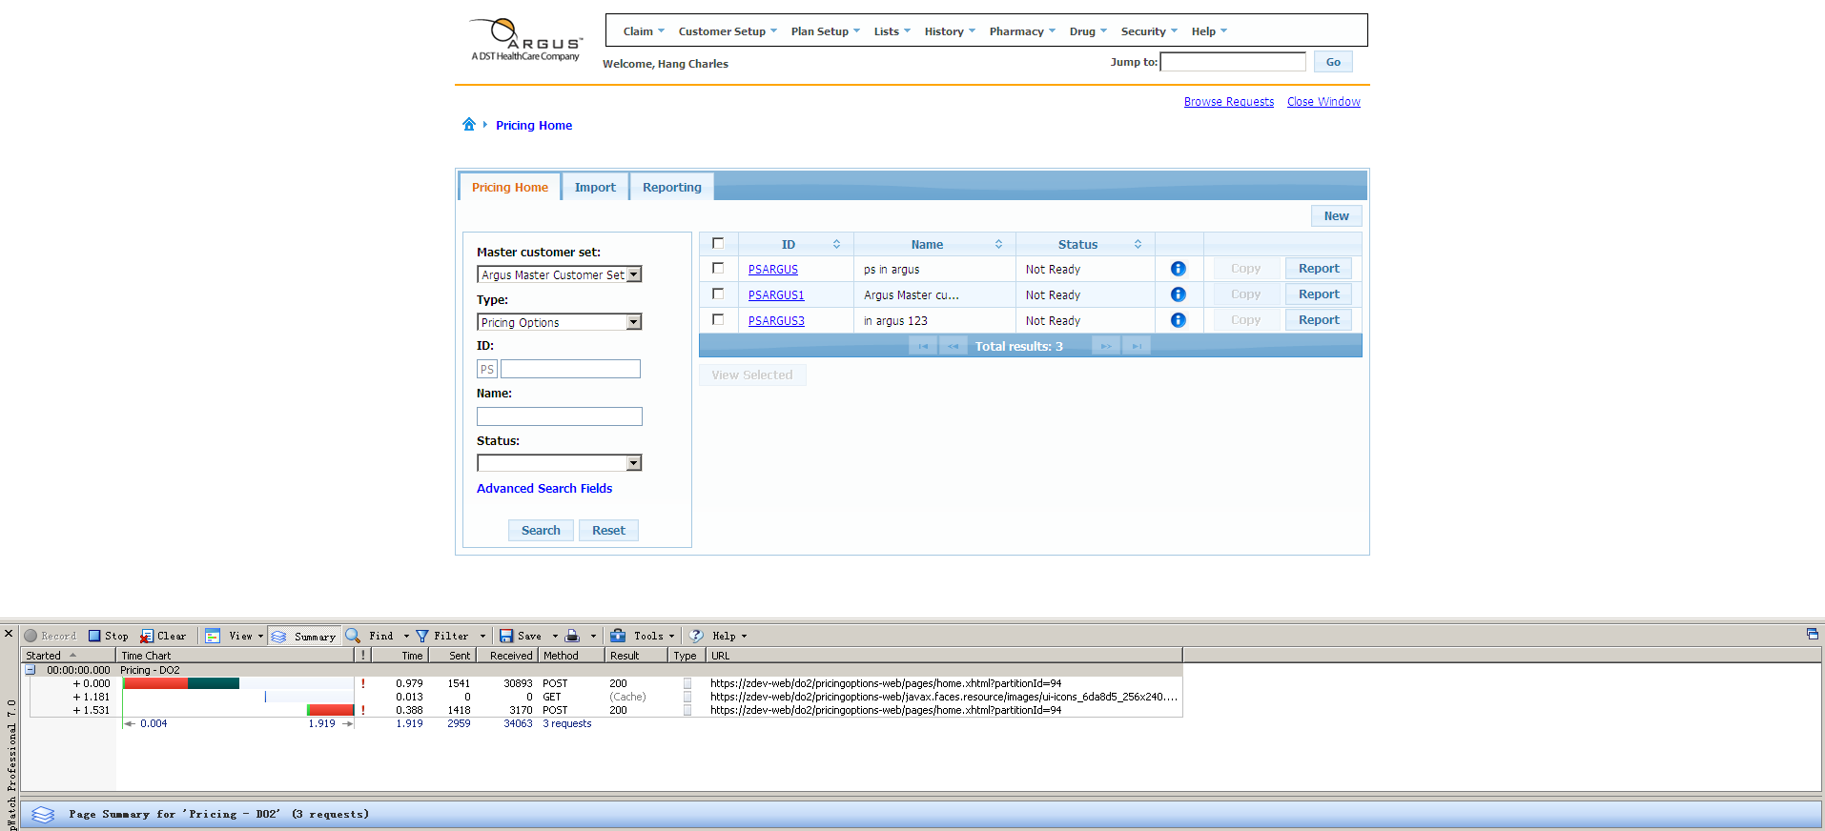

**Issue#5**

|  |  |  |
| --- | --- | --- |
| DrugList | Search by status to getting results | .968 (2.9 with SW) |
| Pricing | Search by status to getting results. | 1.441 Sec (1.5 with SW) |

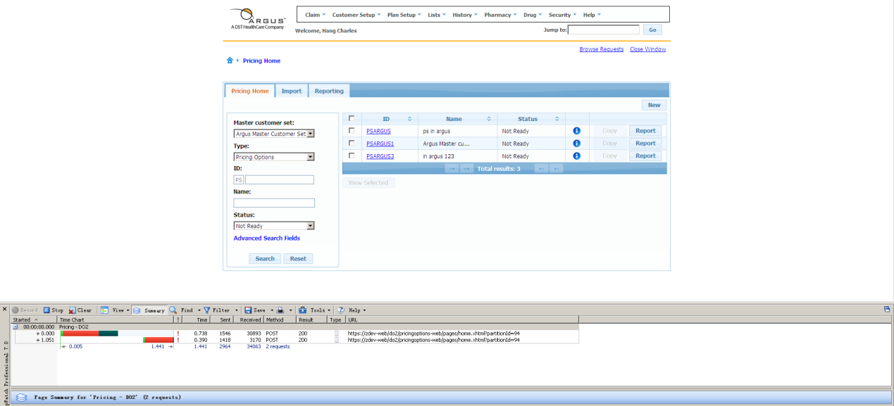

**Issue#15**

|  |  |  |
| --- | --- | --- |
| DrugList | Choosing 1 entry to edit (check box selection) to the time the edit selected button enables | .765 (1.4 with SW) |
| Pricing | Click the check box in the search result to the time the View selected button enables. | 0 |

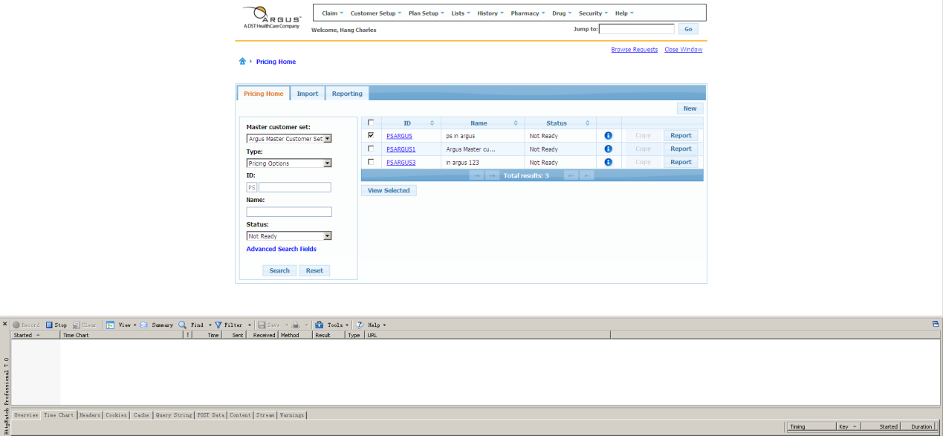

**Issue#27**

|  |  |  |
| --- | --- | --- |
| DrugList | Click on report options button from the drug list tab of the drug list to the time the report pop up is ready to be used | 1.201 (2.2 with SW) |
| Pricing | Click the report button in the entry detail page to the time the report pop up is ready to be used. | 1.594 (1.8 with SW) |

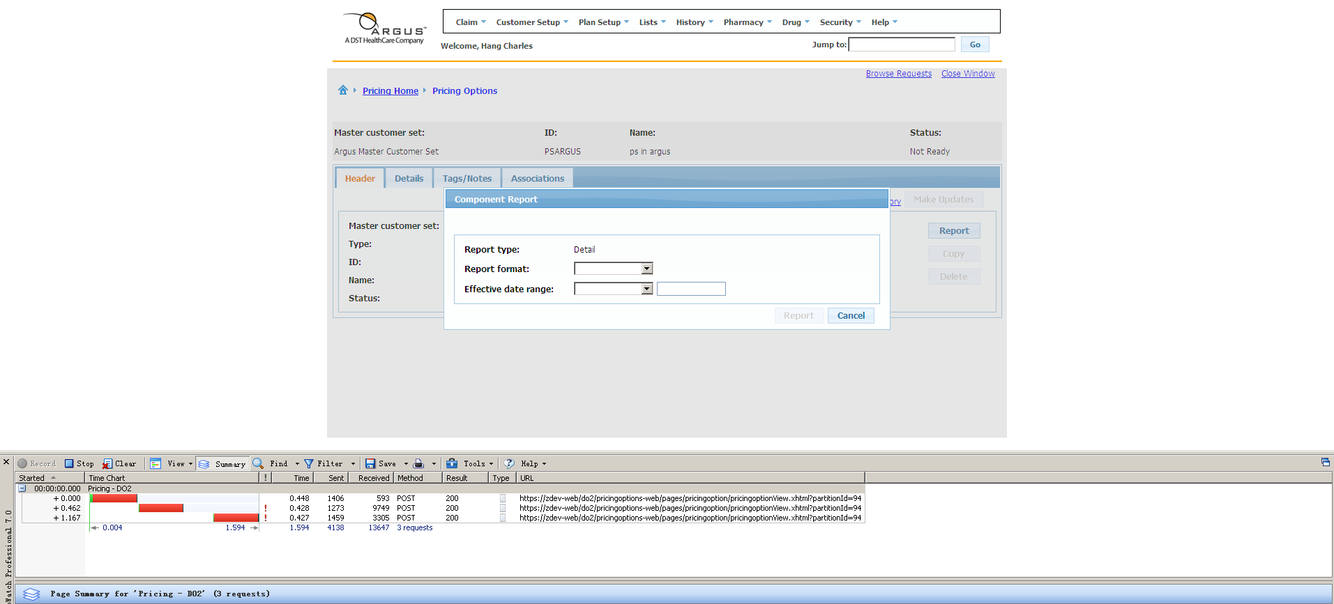

**Issue#30**

|  |  |  |
| --- | --- | --- |
| DrugList | Time between confirm submission pop up OK button selection to the time a successful message is received | 1.355 (2.4 with SW) |
| Pricing | Time between report pop up report button selection to the time a successful message is received | 2.143(2.3 with SW) |

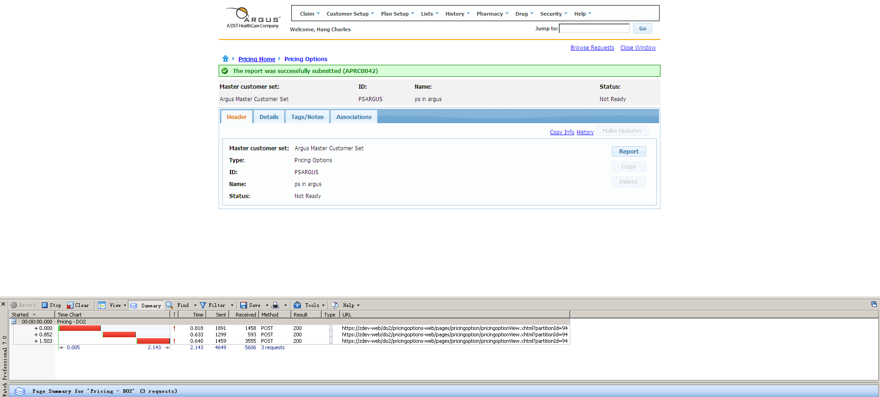

**Issue#31**

|  |  |  |
| --- | --- | --- |
| DrugList | Time to click on browse request to the time the pop up opens | 1.640 (2.5 with SW) |
| Pricing | Time to click on browse request to the time the pop up opens | 2.595 (6.1 with SW) |

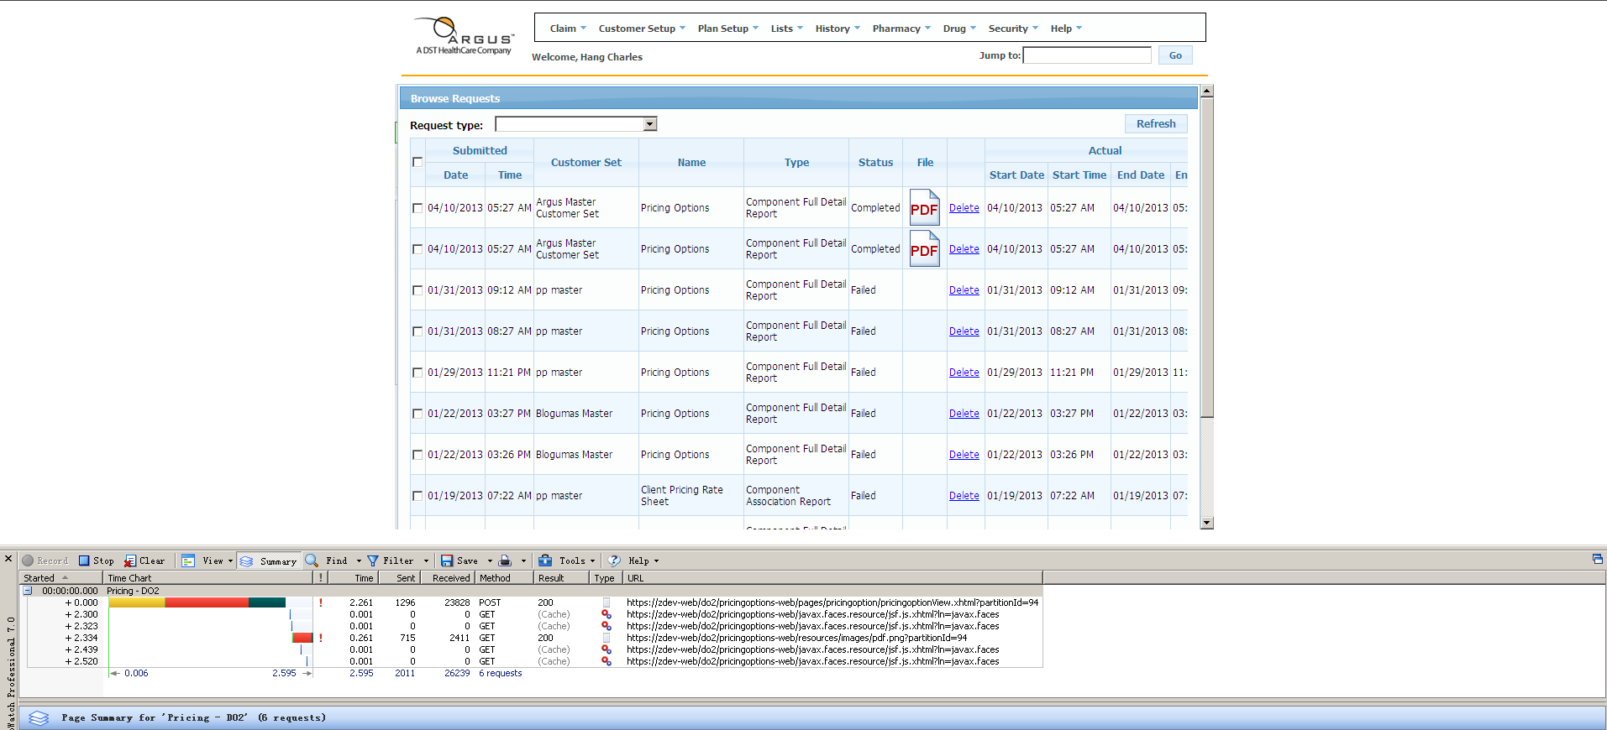

**Issue#37**

|  |  |  |
| --- | --- | --- |
| DrugList | Copy button to copy pop up | 1.239 (2.5 with SW) |
| Pricing | Copy button to copy pop up | 2.168 (2.3 with SW) |

